Metal 3D Printer

# Hardware Description

Cameron Tribe, Brian Andrews,

Ahmad Qazi, Branden Driver

|  |  |  |
| --- | --- | --- |
| **Revision History** | Date | Ver. |
| Cameron Tribe | 5/31/15 | 1 |

**Breakout Boards:**

To easily connect to the Sensoray 826 board, several breakout boards with screw terminals were made. There are two types of break out boards, a 50-pin board and a 26-pin board. 50 pin boards are used to connect to the digital and analog pins of the control board, while 26 pin boards are used to connect to the various counter channels. Shown below are mages of the boards them selves. With the empty side of the board facing you, the screw terminals are in order from 1 to 50/26 starting on the right hand side.

**Image of board:**

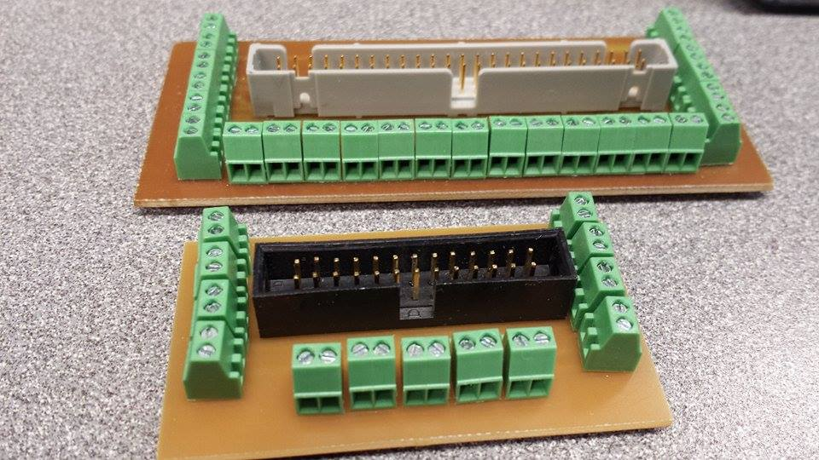

**Layout:**

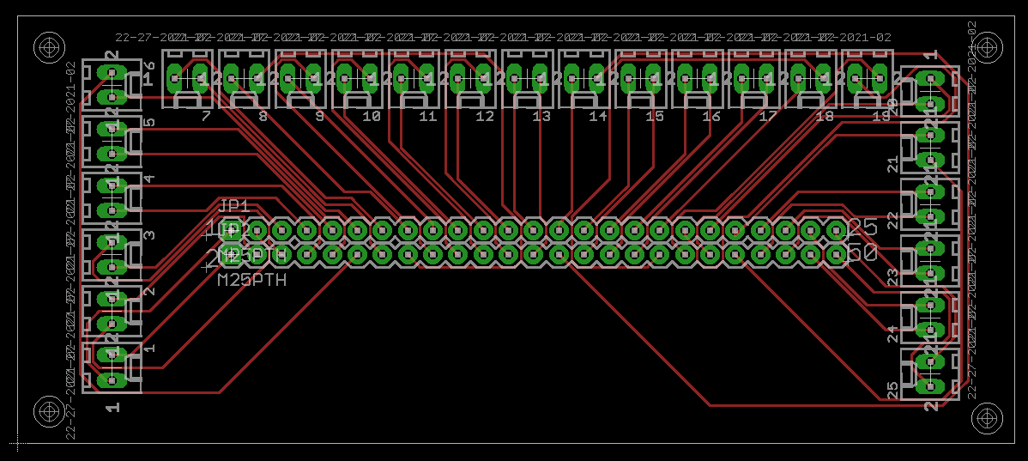

**Temperature Sensor:**

An infrared temperature sensor will be used to measure the temperature surrounding the weld area. These temperature sensors typically have a higher operating range than other types of temperature sensors. The chosen sensor is the CTLM-1M-1H1-CTL-CF4 from Micro-Epsilon. This sensor was chosen of it’s operating range was 800C to 2200C. It has multiple configurable output types, including current output, voltage output, and alarm outputs. This sensor also has a focus point at 450mm (~18 in) which gives considerable distance from the weld, and it is not impractically far away. Further documentation can be found [here](../Documentation/Datasheets%20and%20Manuals/man--thermoMETER-CTL--en.pdf). The Sponsor has agreed to take care of mounting the sensor on the machine.

The chosen output type of the temperature sensor is chosen to be a voltage output with a full-scale range of 0V to 10V. This range was chosen because the ADC on the Sensoray 826 are configurable to accept up to +10V and another Analog input needed the input configured to +10V. Setting the output range to 0V-10V on the current sensor removed the need to write additional software to solve an issue that was solved in other means.

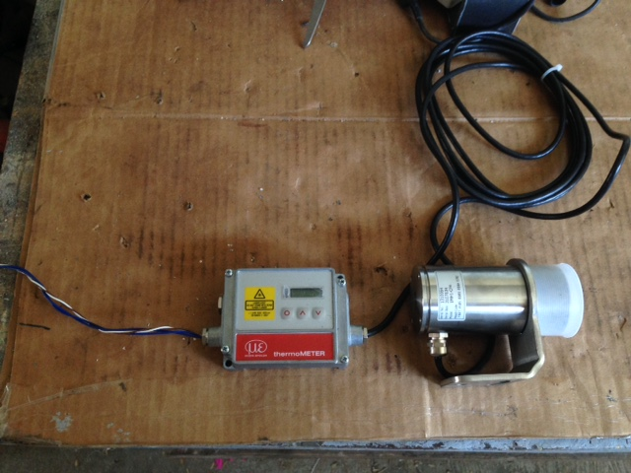

**Incremental Encoder:**

The Incremental Encoder is used to measure the actual wire speed of the welder wire. The encoder needed to be incremental because of the need to know speed, and that current position did not matter. The chosen encoder is the U.S. Digital S5-5000-250-IE-D-B. Initially a pulley on a shaft type encoder was going to be used. The pulley be mounted to the frame of the welder and the encoder would be placed under tension underneath the wire that is being fed to the weld. However this was not successful as there could not be any external tension placed on the wire inside the welder.

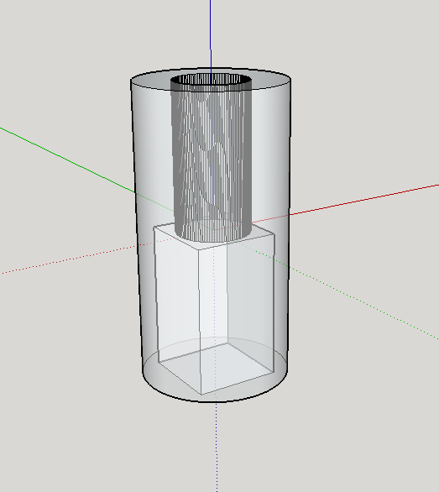Fortunately the main drive pulley has a square drive shaft and stuck out past the edge of the pulley. A small plastic “coupler” piece was 3D printed that adapted the round end of the encoder, to the square drive shaft of the drive pulley. The CAD drawing of this part can be seen to the left. This piece allowed an accurate measurement of the actual wire speed of the welder to be interpreted by the Sensoray 826. [Here](../Hand%20Calculations/Wire%20Speed%20with%20Encoder.pdf), the calculations for the wire speed can be found.

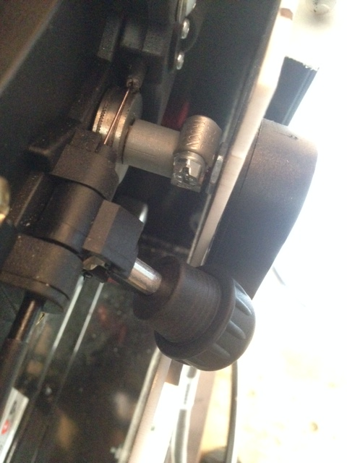

**Relay and Indication Module:**

A relay was used to interface the Sensoray 826 with the welder. A relay provides isolation from any harmful voltage spike that occurs on the welder’s circuit. It also acts as a mechanical switch, which is the same as the trigger on the welder gun itself. It is unknown what type of signal is passed through the welder switch weather its DC, or AC the relay will on act differently, as a transistor might. The interface circuit includes a transistor drive circuit that switches an 8V supply (which comes from a wall wart power supply) across the coil of the relay on and off. This module also includes LEDs to indicate what state the CNC machine is currently in. A schematic and an image of the final module can be seen below.

There were some issues with the relay module, where were that the Sensoray 826 has internal 10k pull up resistors, and when the machine powers up, the active low DIO pins are initialized to a 0-state, which means that the voltage is high on the pin. When connected to the welder, this meant that when there was not any code being executed the welder would be activated. To remedy this issue, an inverter was placed on the input.

Schematic: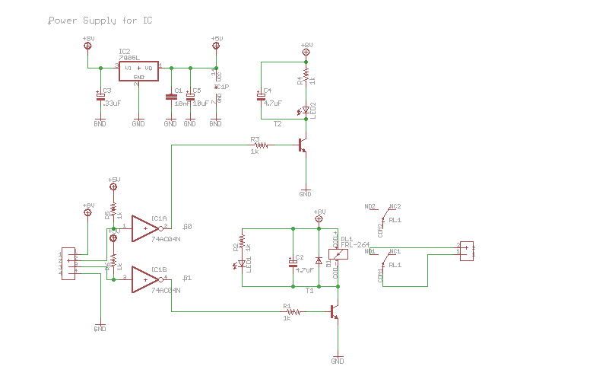

Layout:

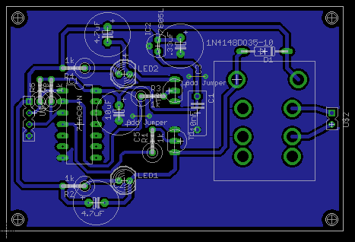

Image:

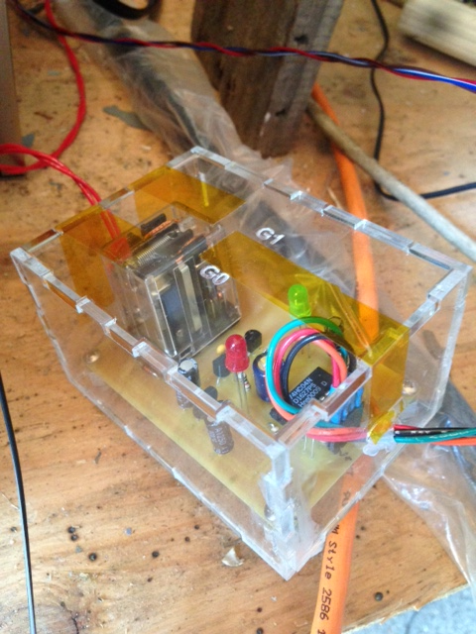

**Stepper Motor Controller:**

**P/N:**

**Controller:** KL-5056

**Motor:** KL23H2100-35-4B

The stepper motor controller is used to control a motor that adjusts the wire speed knob on the welder. From the Sensoray 826, there are two digital signals that control how much and in which direction the motor turns. To tell the motor two turn, a PWM signal with a 50% duty cycle is used. The frequency determines the speed of rotation. The direction signal is either a high or low 5V signal that will turn the motor clockwise or counterclockwise. The controller also has a programmable step resolution, which is either defined in software, or by using the DIP switched located on the side of the controller. Further documentation on the controller can be found [here](../Documentation/Datasheets%20and%20Manuals/KL-5056D.pdf).

The motor is coupled to the wire speed adjustment knob via a PVC cylinder, which have elevated surfaces where the limits of the knob are. Shown below, are switches that get triggered if the motor turns too far. The limit switches are connected to the enable pin of the motor controller, so that if the motor accidentally turns too far, it will disable its self and it will not damage the knob on the welder. An additional switch is added to the PVC cylinder, which is used as a reference position of the knob. Shown below is the wiring diagram of the motor controller.

Wiring Diagram

Pictures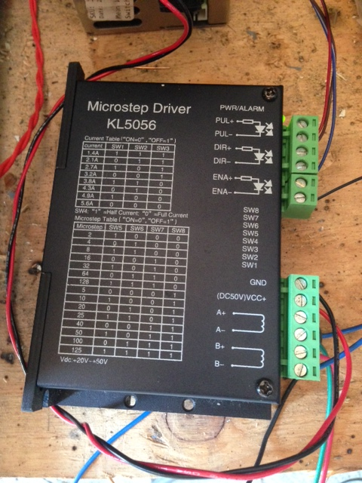

**PWM Controller:**

**P/N:** Mesa THC A-D

The PWM controller is a voltage to frequency converter. It is used to externally start and stop the CNC machine. The voltage input of the PWM controller is connected to a digital output of the Sensoray 826. To stop the CNC Machine, a 5V signal is send and to stop it is 0V. The CNC machine is initialized to use this 5V signal in the .HAL file associated with that machine. In fact the voltage on that pin can be anywhere between 0V and 5V for further external control of the welder, however in the scope of this project, only a high or low signal needs to be sent.

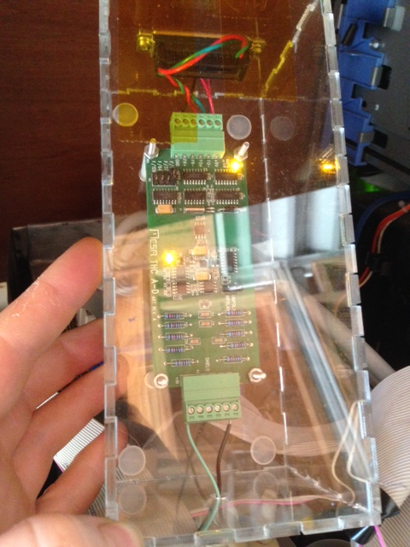

**Current Sensor:**

**P/N:** CSLA1DJ

This current sensor has an operational range of 0 to 225A, which is well over the maximum current of the welder. It is placed in a small plastic housing, which a jumper cable is passed though. The sensor is a Hall effect sensor that is placed inside a ferrite toroid. The output of the sensor is a voltage that sits at half of the supply voltage, and will deviate above or below that level based on he magnitude and direction of the current. There is a metal lug, which the ground connection of the welder connects to. The other end of the module is a large alligator clamp that connects to the plate being welded to.

Schematic

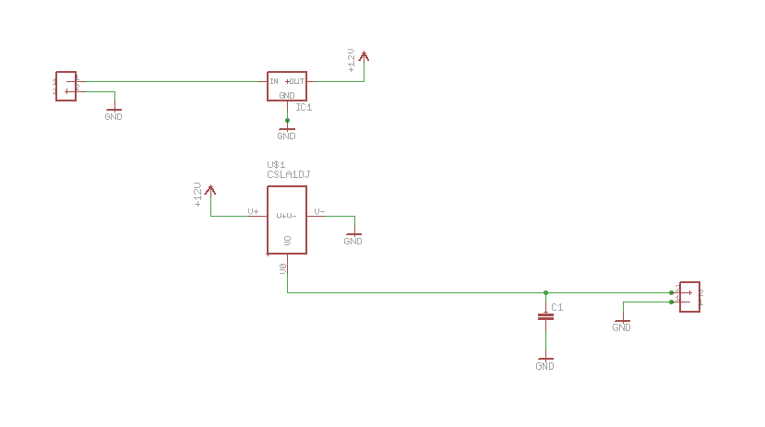

Layout

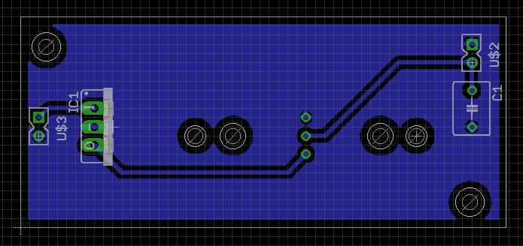

Picture

